**Name: SHAMJAD MAZOOD NAZER**

**Roll No:36**

**Batch:S2 RMCA**

**Date:05\04\2022**

**NETWORKING & SYSTEM ADMINISTRATION LAB**

**Experiment No.: 2**

**Aim:** Hardware Components

**Procedure:**

1. **MOUSE**

* A mouse is a hardware input device that is used to move the cursor or pointer on computer screens.
* It can also be used to run computer programs, select items in a graphical user interface, and manipulate objects in the computer world.
* Some common examples of how it can be used are clicking on buttons, scrolling up and down the screen, selecting files, opening folders, and so on.

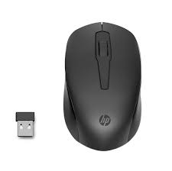

1. **KEYBOARD**

* A keyboard is an input device that you use to enter data into a computer.
* It's also called the input device for your computer.
* Keyboards are used with PCs, laptops, tablets, and other devices.
* There are many different types of keyboards, but the most common one is the QWERTY keyboard.
* A QWERTY keyboard has all the letters in alphabetical order on it.
* This is different from some other types of keyboards, like Dvorak or Colemak keyboards.
* For example, these keyboards have keys arranged differently than what you’re used to seeing on a QWERTY keyboard.
* And that means that typing on these keyboards will feel like typing in another language at first! But don’t worry - once you get accustomed to it, it feels natural!

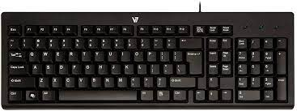

1. **MONITOR**

* Personal computers use a monitor to display data, run the software, and interact with the user.
* A monitor is an electronic visual display that connects to your computer or laptop.
* It is used for displaying images, text, videos, games, web pages, and more.
* Monitors are available in different sizes depending on the needs of the person using them.
* The most common types of monitors are CRT (cathode ray tube), LCD (liquid crystal display), and LED (light-emitting diode).

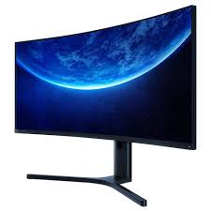

1. **MOTHERBOARD**

* The motherboard is the backbone of our computer system.
* It's the central processing unit or CPU.
* It connects all the other components, like memory and graphics card, to the power supply.
* The motherboard is where all the wires are plugged in and it's also where you place your RAM, which is your computer's working memory.
* The motherboard is what makes one machine different from another.
* Motherboards are made up of tiny transistors that control the flow of electricity through copper tracks on their surface.
* These transistors are called Integrated Circuits or ICs for short.

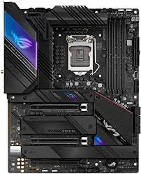

1. **CPU (Central Processing Unit)**

* A CPU, or central processing unit, is the brain of a computer.
* The CPU processes information and runs programs.
* It functions as a control unit that executes programs according to instructions in its program memory.
* The CPU contains elements such as registers, an arithmetic logic unit (ALU), and control logic for sequencing instructions.

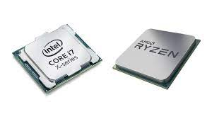

1. **RAM (Random Access Memory)**

* A computer's RAM is a type of computer memory that stores information so the CPU can access it directly.
* Computer systems use main memory to store both data and programs.
* The more RAM you have, the more data your system can process at one time.
* This will lead to more efficient operations on your computer, which translates into better performance for the user.

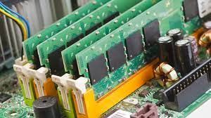

1. **ROM (Read Only Memory)**

* ROM stands for a type of memory chip that can be read from but not written to.
* In other words, it's a form of data storage that can't be changed after being programmed.
* It's sometimes called "non-volatile" memory because the stored information will remain even when not powered up or in use.
* ROM is often used to store a computer's basic start-up instructions and certain types of data, such as your car's onboard computer system and a calculator's data tables.

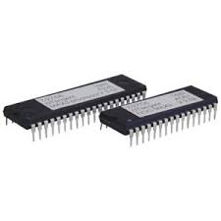

1. **HARD DISK DRIVE**

* A hard disk drive is a piece of hardware inside a computer that stores information.
* It's used to store software and data in a safe place, which can be accessed when needed.
* With magnetic storage, there are no moving parts - unlike a CD or DVD player in which you need to move a disk in order to access data.
* You can think of it as "a closet" where all your stuff is stored safely.
* As long as you have power, you can get to your things when you need them.

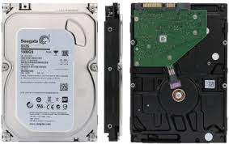

1. **OPTICAL DRIVE**

* Optical Drives are used in PCs to read and write CDs and DVDs.
* The optical drive reads the data from the disc, which can then be transformed into a digital file that is readable by the computer.
* This makes it easy to backup files, play music or movies, or copy data from one disc to another.
* The term "CD" refers to Compact Discs, which are the most common type of optical drive on modern computers.
* They are often used for installing software on your computer, moving data between computers, or writing new programs.

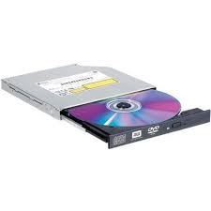

1. **IO System**

* The IO system is the set of devices that are used to access data.
* There are three major parts of the IO system: input, output, and storage.
* Input devices, also called input peripherals, are typically what data is first inputted into the computer.
* Output devices are where data is displayed. Storage devices store data so it does not need to be present in memory or processed by a CPU.

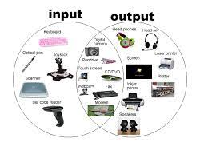

1. **POWER SUPPLY**

* A power supply is an electrical appliance that provides the necessary power to operate a computer.
* Computers are powered by electricity, and the power supply converts the alternating current (AC) from the electric outlet into direct current (DC).
* The power supply in a computer can be an internal or external component.
* It’s important to make sure your power supply is functioning properly.

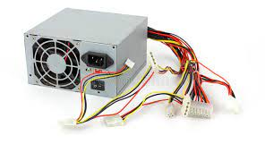

1. **EXTERNAL PORTS**

* External ports are used to connect your computer to other devices like printers and speakers, among many others.
* However, not all external ports are the same. You’ll find different types of ports on laptops and desktops that allow you to use them in different ways.

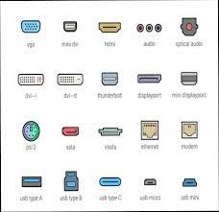

1. **CPU FAN**

* The CPU fan in the computer is a very important component for your PC.
* If your CPU fan is not working correctly, your computer will be overheating and it may cause damage to other components.
* The CPU fan helps cool the CPU and other internal parts of the computer.
* It also provides negative pressure and removes dust and debris from the inside.

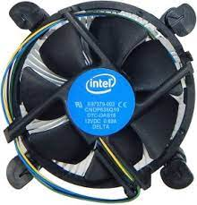

1. **SOUND CARD**

* A sound card is a computer chip that processes and amplifies sounds.
* It produces a signal to the speakers, headphones, or other output devices.
* The sound card can also be called a "sound card" or "audio card."
* Computers with sound cards are capable of playing digital music files and videos, as well as speech synthesis.
* Sound cards were originally provided as an external device for home computers in the 1980s.
* With the development of microprocessors, sound capabilities were integrated onto motherboards during the 1990s.
* Nowadays, most computers have these built-in.

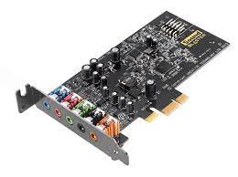

1. **VIDEO DISPLAY CONTROLLER**

* Video display controllers (sometimes shortened to VDC) are circuits found in video cards, which control the video output of the computer.
* The controller is responsible for formatting the data that is sent to the monitor or TV.
* Video display controllers can be implemented by either an onboard circuit on the motherboard or a separate card that connects to the motherboard through a slot.

